Veeva Integrated Program GrandTest

Q5 :
- Create a test case for exploratory testing
- Track the progress of a specific release or sprint

- Create a test case for exploratory testing

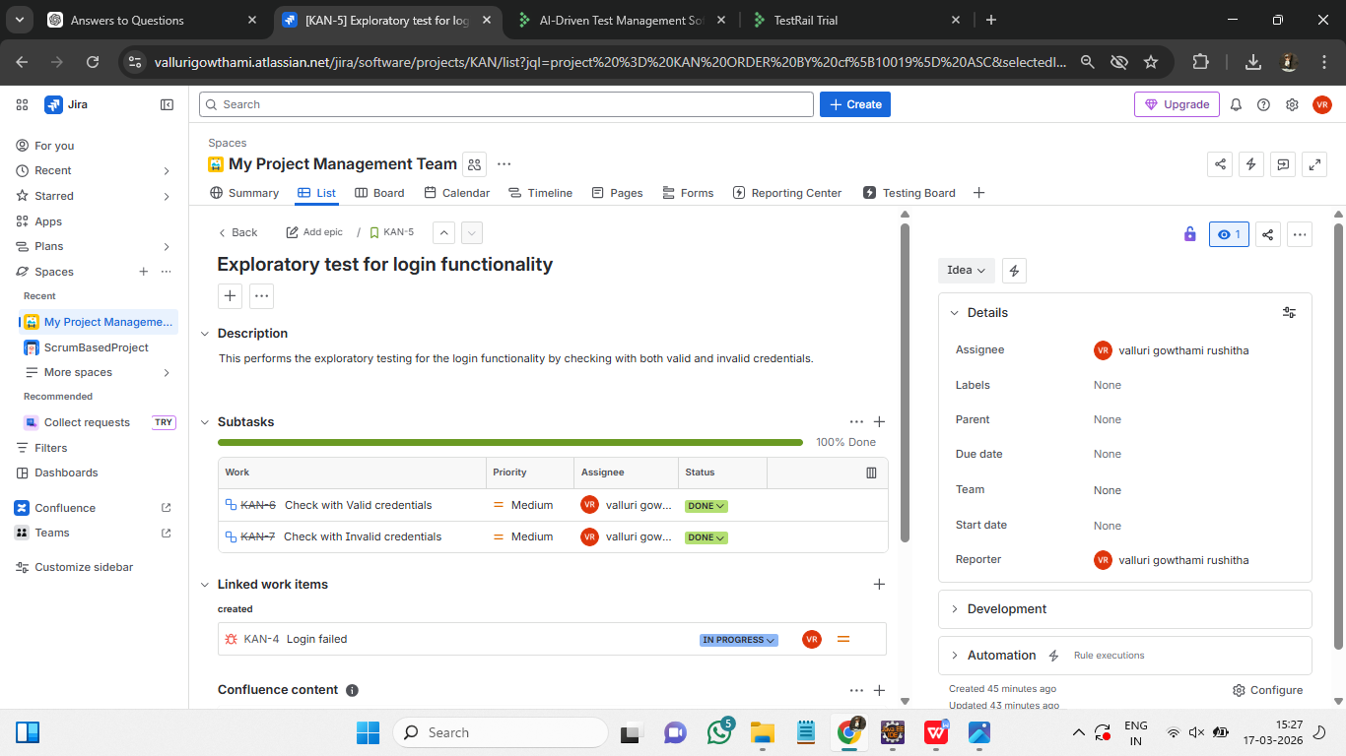
Steps to create a test case for exploratory testing :
- Create a test issue : Go to jira and create an issue with issue type=Test
- Fill the summary and description with test details.
- In xray, set test type=Exploratory and add Goal
- Execute the test by creating test execution and adding the test.
- Record the results.
- If failed, create a bug and link it to the test.

- Track the progress of a specific release or sprint
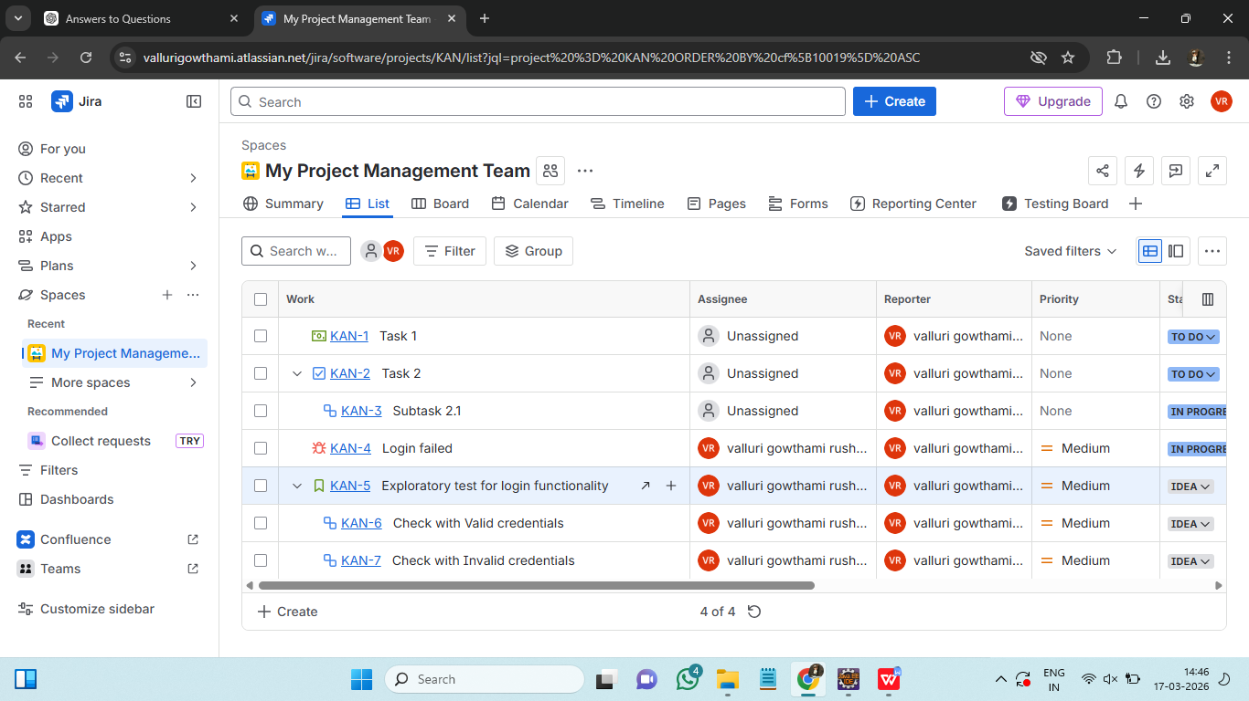
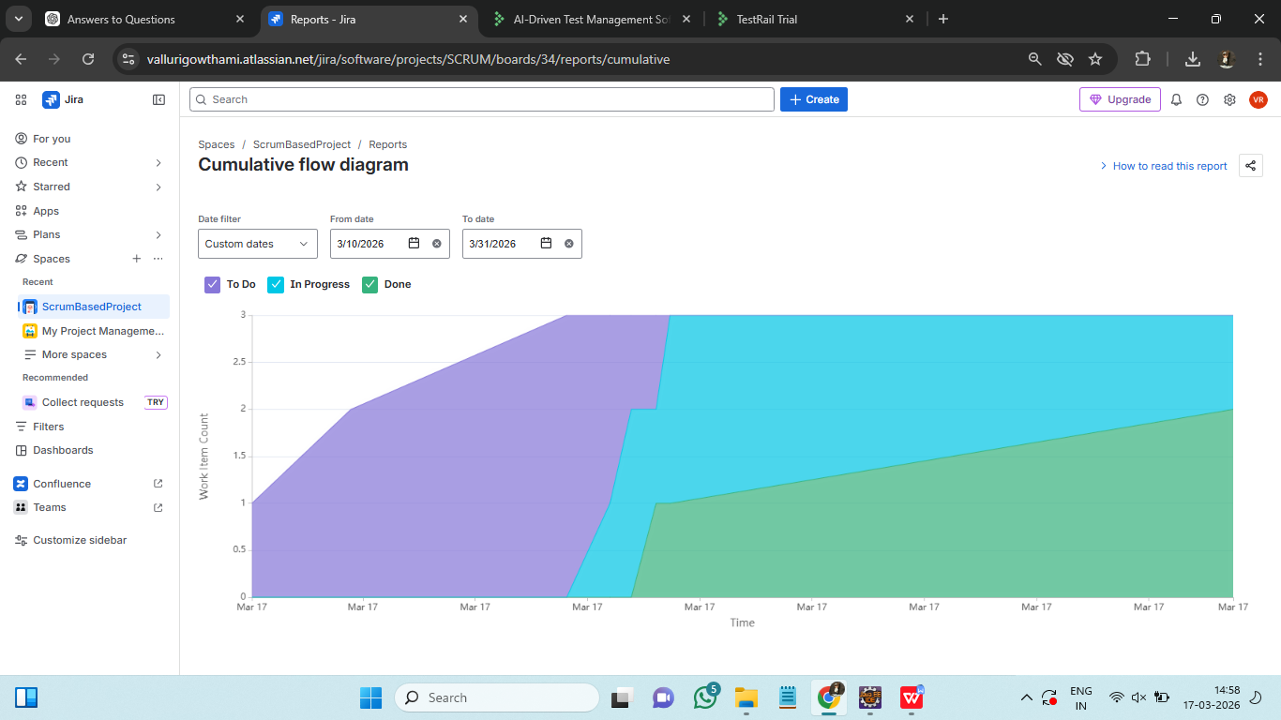
Steps to track the progress of a specific release or sprint :
- Go to jira Reports and select Sprint BurnDown Chart.
- Select the sprint which we want to track.
- It shows remaining work vs time and validates whether sprint is on track or not.

